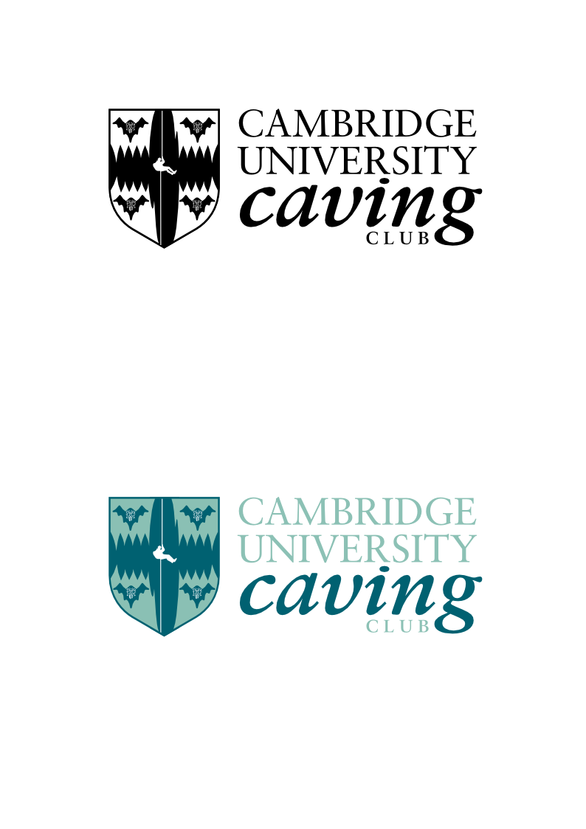

Your address

Tuesday, 8th May 2014

Dear Sir or Madam,

I am writing on behalf of the Cambridge University Caving Club to enquire as to whether it will be possible to get permits for X and Y for next Saturday and Sunday, 10th and 11th of May 2014.

If you have any queries please do not hesitate to contact me as I would be more than willing to provide additional information.

We look forward to hearing from you.

Yours sincerely,

Your name
CUCC Your position

